# Istio lab

Installing Istio:

Install for demo configuration:

(I ran this command but forgot to screenshot the output before closing my computer)

Starting minikube and labelling the namespace for istio to automatically inject Envoy sidecar proxies

Installing the Kubernetes Gateway API CRDs:

Applying bookinfo sample:

Evidence of deployment:

Opening application to traffic externally:

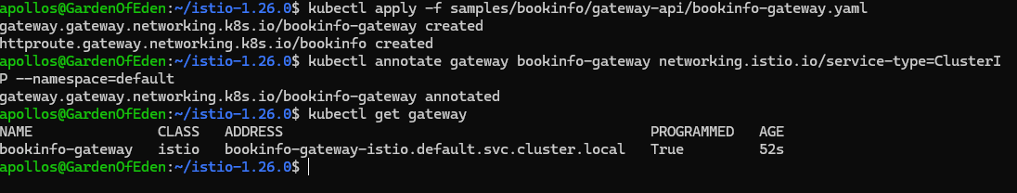

Evidence it works:

Installing Kiali and the other addons:

Kiali being rolled out:

